

Directory Facilitator (DF) agent and Services

The Directory Facilitator (DF)

The DF is a system agent integrated into JADE that implements the Yellow Pages service. Its role is to register and search for agents based on the services they offer. An agent can:

• Register with a service type and name via DFService.register()

• Search for agents offering a given service via DFService.search()

• Deregister at the end of its lifecycle via DFService.deregister()

Exercise 1 — Communication BuyerAgent / SellerAgent

Establish communication between a buyer agent and a seller agent via the DF. The buyer sends a request to obtain the list of available cars; the seller responds with this list in the form of a serialized object:

• BuyerAgent: registers with the DF, sends a request to seller1 using its AID, receives the list, and sends "Bye".

• SellerAgent: registers with the DF (car-selling service), waits for messages in a cyclic manner, sends the serialized list of cars, and terminates upon receipt of "Bye".

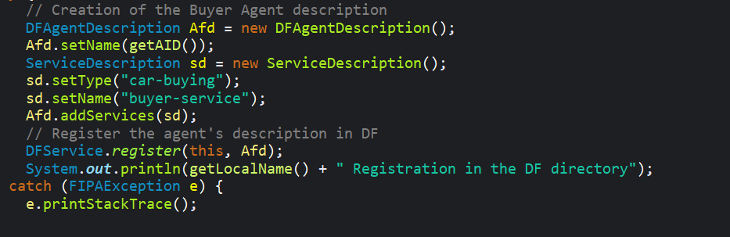
- The Seller agent receives the request for the products list and responds to the Buyer agent by sending to it the product list:

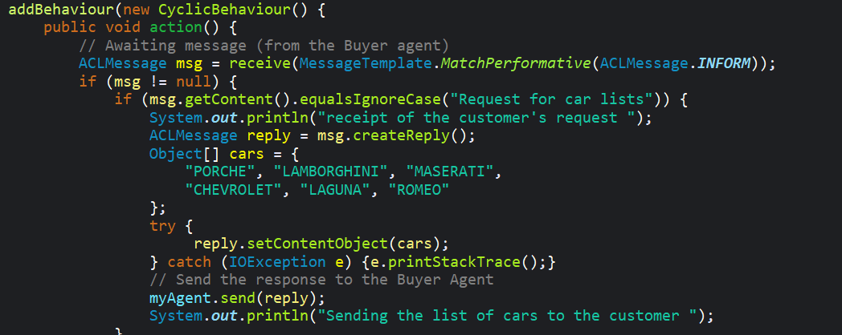
Result on the console:

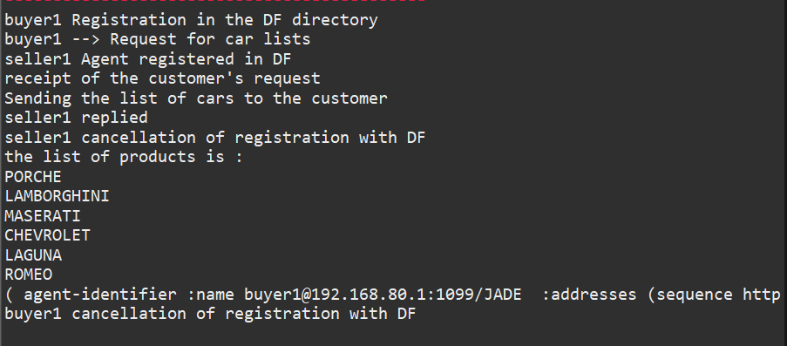

CarBuyerAgent (Buyer1) $⟶$“request for car seller ” $⟶$ CarSellerAgent (Seller1) $⟶$ Available cars list $⟶$ CarBuyerAgent (Buyer1) $⟶$ “Bye” $⟶$ CarSellerAgent (Seller1) $⟶$“Bye”

Exercise 2
Three agents are created in the Lab5.exercice2 package:
• CarSellerAgent: publishes the "car-selling" service in the DF. Responds to requests for lists of cars.
• BookSellerAgent: publishes the "book-selling" service on the DF. It will not be contacted by the CarBuyer.
• CarBuyerAgent: searches the DF for the agent offering "car-selling", dynamically retrieves its AID, then sends it the request.

Code snippet — Searching the DF
The searchCarSellerInDF() method sends a targeted query to the DF using the "car-selling" service type:
CarBuyerAgent $⟶$DF : “search car selling” $⟶$ AID of CarSellerAgent $⟶$ CarBuyerAgent
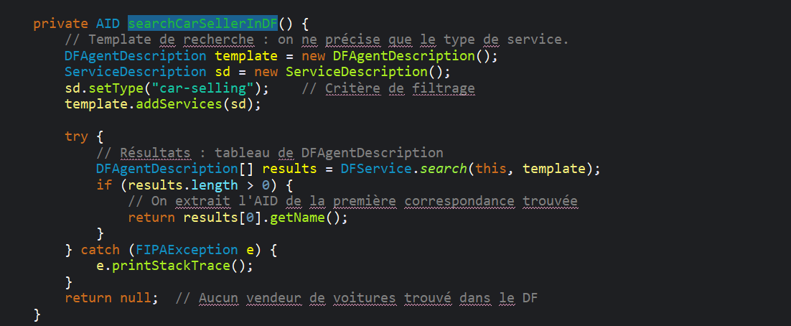
How to use it:
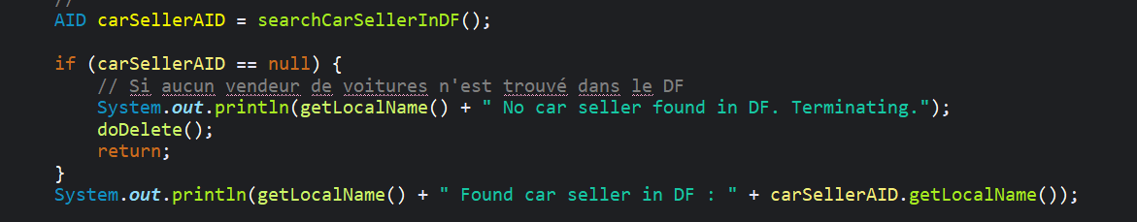

CarBuyerAgent $⟶$ “Request for Cars list” $⟶$ CarSellerAgent $⟶$“Sending the list of cars to the customer” $⟶$ CarBuyerAgent $⟶$ “Bye” $⟶$ CarSellerAgent (Seller1) $⟶$“Bye”

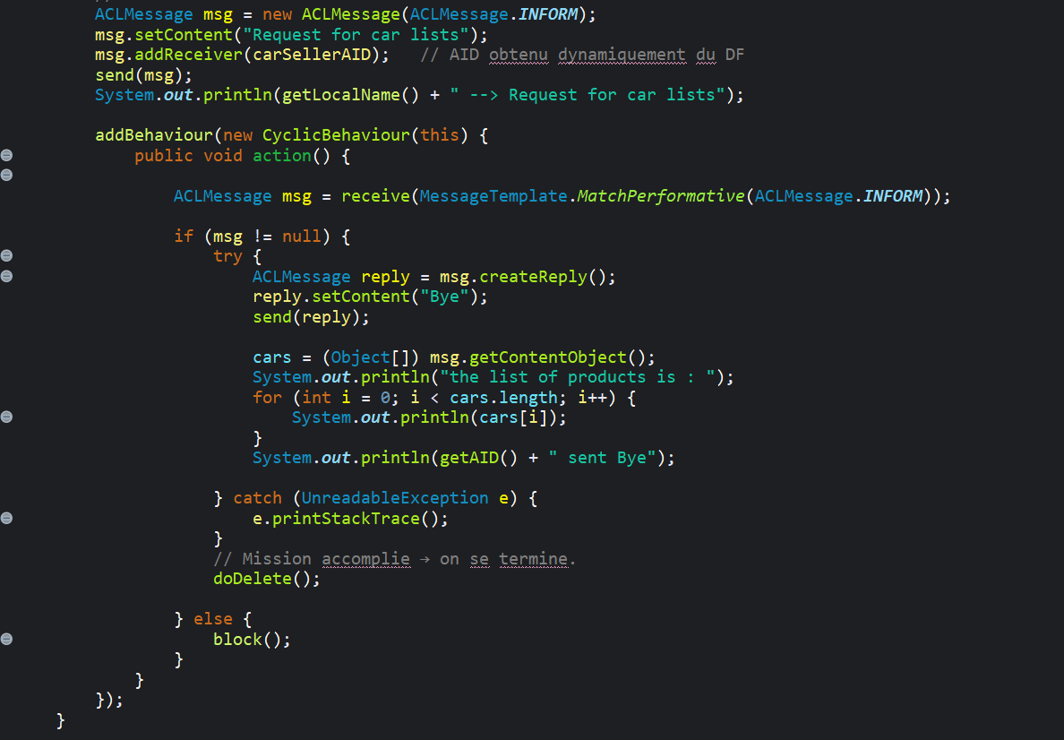

Results on the console:
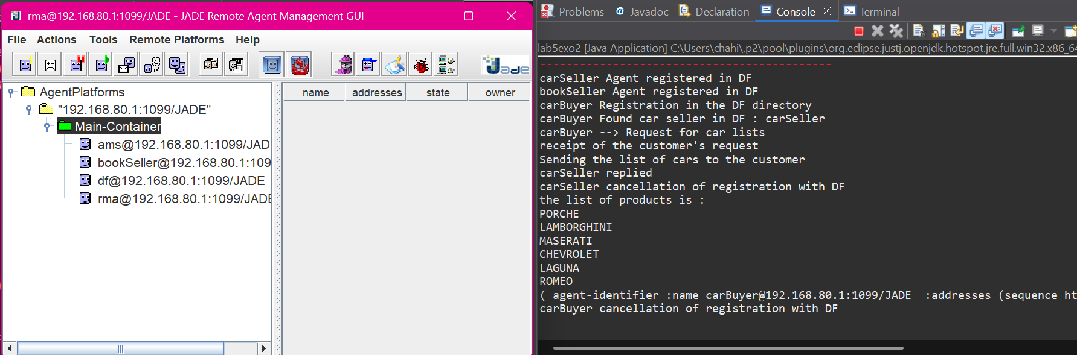

Conclusion
This practical exercise provided a practical understanding of two fundamental mechanisms of multi-agent systems in JADE:
- Dynamic manipulation & filtering of the DF (the agents start up on their own and each log in to the DF using their own service type).
- ACL communication with serialised objects: using setContentObject / getContentObject allows complex data structures (arrays, Java objects) to be exchanged between agents.

